Design a Database
Ryan Coon
SDD-620
Dr. Benjamin Perez
August 12, 2026

Introduction
Database design consolidates various user perspectives into a unified representation of business operations. For this online video rental store, the design must capture information about customers, rentable movie copies, rental invoices, suppliers, and purchase orders. Although described as a streaming store, the system manages rentals at the individual copy level, including due dates, returns, and late fees, functioning like a traditional rental inventory. Consequently, each copy is modeled as a separate rentable entity. PostgreSQL is chosen for the logical design due to its robust support for primary keys, foreign keys, composite constraints, precise numeric data types, and check constraints.
Conceptual View
The conceptual model starts with the Movie entity, which includes the unique MovieCode, title, and daily late-charge fee. There is a one-to-zero-or-many relationship between Movie and Copy: a single movie can have multiple physical or licensed copies, while each copy is associated with exactly one movie. Similarly, Supplier has a one-to-zero-or-many relationship with Copy, as a supplier can provide many copies, but each copy is linked to only one supplier. Although NumberOfCopies is an important business metric, it is not stored directly; instead, it is derived by counting the number of Copy records for each movie. Omitting this derived attribute helps avoid update anomalies when inventory changes occur.
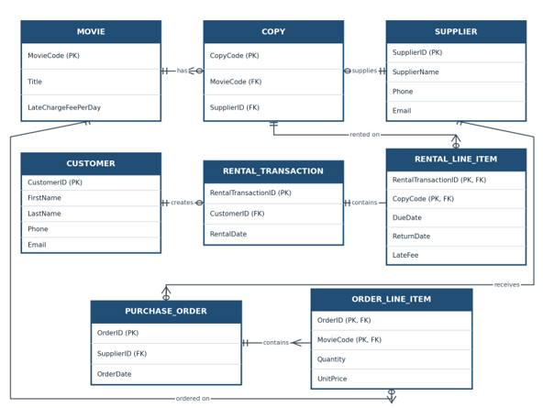
Figure 1. Crows foot ERD
Customer and Copy share a many-to-many relationship over time, which is managed through the RentalTransaction and RentalLineItem entities. A customer can have zero or many rental transactions, but each transaction is linked to one customer and must include at least one line item. The RentalLineItem table uses a composite primary key consisting of RentalTransactionID and CopyCode, enabling a single invoice to include multiple copies while preventing duplicate entries of the same copy on that invoice. Attributes such as DueDate, ReturnDate, and LateFee are associated with each line item because different copies within the same transaction can have varying due and return dates. Consequently, the transaction header only records the RentalDate.
Supplier orders follow a similar structure. Each Supplier can have multiple PurchaseOrder records, and each order contains one or more OrderLineItem records. Each order line specifies a movie title, quantity, and unit price, referencing MovieCode rather than CopyCode since individual copy identifiers are assigned only after the ordered units are received. The term PurchaseOrder is used instead of Order because ORDER is a reserved keyword in SQL.
Normalization Visualization
The relations comply with the first normal form as all attributes are atomic; for instance, general contact information is separated into phone and email fields, and the customer name is split into first and last names. They meet the second normal form because every non-key attribute in tables with composite keys depends on the entire key. The relations also satisfy the third normal form since non-key attributes do not depend on other non-key attributes. For example, supplier information is stored exclusively in the Supplier table, and movie details are not duplicated in the Copy or OrderLine tables. Although LateFee can be calculated, it is reasonable to store it as the final recorded historical charge.
Logical View
The ERD is implemented in the PostgreSQL schema shown below. Integer identity columns automatically generate unique identifiers for transactions, customers, suppliers, and orders. Alternatively, MovieCode and CopyCode can use store-assigned integer codes. Foreign key constraints maintain all parent-child relationships. NOT NULL constraints ensure essential data is present, UNIQUE constraints prevent duplicate email addresses for customers and suppliers, and CHECK constraints disallow negative values for fees, prices, or quantities. The ReturnDate field remains nullable until a copy is returned. Typically, referential actions restrict deletion of referenced historical records, while application-level transactions should atomically insert each invoice header along with its associated line items.
Database Schema:
CREATE TABLE MOVIE (
MovieCode SERIAL PRIMARY KEY,
Title VARCHAR(255) NOT NULL,
LateChargeFeePerDay NUMERIC(5,2) CHECK (LateChargeFeePerDay >= 0) NOT NULL
);

CREATE TABLE SUPPLIER (
SupplierID SERIAL PRIMARY KEY,
SupplierName VARCHAR(255) NOT NULL,
Phone VARCHAR(20),
Email VARCHAR(255) UNIQUE
);

CREATE TABLE COPY (
CopyCode SERIAL PRIMARY KEY,
MovieCode INT NOT NULL,
SupplierID INT NOT NULL,
FOREIGN KEY (MovieCode) REFERENCES MOVIE(MovieCode),
FOREIGN KEY (SupplierID) REFERENCES SUPPLIER(SupplierID)
);
CREATE TABLE CUSTOMER (
CustomerID SERIAL PRIMARY KEY,
FirstName VARCHAR(100) NOT NULL,
LastName VARCHAR(100) NOT NULL,
Phone VARCHAR(20),
Email VARCHAR(255) UNIQUE
);
CREATE TABLE RENTAL_TRANSACTION (
RentalTransactionID SERIAL PRIMARY KEY,
CustomerID INT NOT NULL,
RentalDate DATE NOT NULL,
FOREIGN KEY (CustomerID) REFERENCES CUSTOMER(CustomerID)
);
CREATE TABLE RENTAL_LINE_ITEM (
RentalTransactionID INT NOT NULL,
CopyCode INT NOT NULL,
DueDate DATE NOT NULL,
ReturnDate DATE,
LateFee NUMERIC(6,2) CHECK (LateFee >= 0),
PRIMARY KEY (RentalTransactionID, CopyCode),
FOREIGN KEY (RentalTransactionID) REFERENCES RENTAL_TRANSACTION(RentalTransactionID),
FOREIGN KEY (CopyCode) REFERENCES COPY(CopyCode)
);
CREATE TABLE PURCHASE_ORDER (
OrderID SERIAL PRIMARY KEY,
SupplierID INT NOT NULL,
OrderDate DATE NOT NULL,
FOREIGN KEY (SupplierID) REFERENCES SUPPLIER(SupplierID)
);
CREATE TABLE ORDER_LINE_ITEM (
OrderID INT NOT NULL,
MovieCode INT NOT NULL,
Quantity INT CHECK (Quantity > 0) NOT NULL,
UnitPrice NUMERIC(8,2) CHECK (UnitPrice >= 0) NOT NULL,
PRIMARY KEY (OrderID, MovieCode),
FOREIGN KEY (OrderID) REFERENCES PURCHASE_ORDER(OrderID),
FOREIGN KEY (MovieCode) REFERENCES MOVIE(MovieCode)
);
This design effectively represents both customer rentals and vendor purchases without using repeating groups or leaving many-to-many relationships unresolved. It maintains a complete operational history while enabling precise reporting of inventory levels and overdue fees. By separating transaction headers from line items, the model supports invoices that include multiple copies or movie titles, providing end users with a reliable overview of the store’s rental and supply operations.

References
Codd, E. F. (1970). A relational model of data for large shared data banks. Communications of the ACM, 13(6), 377–387. https://doi.org/10.1145/362384.362685
Coronel, C., & Morris, S. (2023). Database systems: Design, implementation, & management (14th ed.). Cengage Learning.
Microsoft. (n.d.). Create a diagram with Crow’s Foot database notation. Microsoft Support. https://support.microsoft.com/en-us/visio/create-a-diagram-with-crow-s-foot-database-notation
PostgreSQL Global Development Group. (2026). PostgreSQL 18 documentation: Constraints. https://www.postgresql.org/docs/current/ddl-constraints.html

